CMPE 306

Spring 2020

Lab 8: Op Amps 2: Integrator and Differentiator

Circuits

Nem Negash

April 2nd, 2020

**Purpose**

The purpose of this lab is to study the use of an operational amplifier to implement circuits that provide integration and differentiation of analog input signals. The simulation circuits show the characteristics of integrator and differentiator circuits including the simulated data that shows the input and output values of the circuits. The lab furthermore shows the limitation of the differentiator and integrator circuits as a function of the frequency of the input signal.

**Equipment**

1. LTSPICE application

**Procedure**

* 1. **Op-Amp based integrator circuit:**

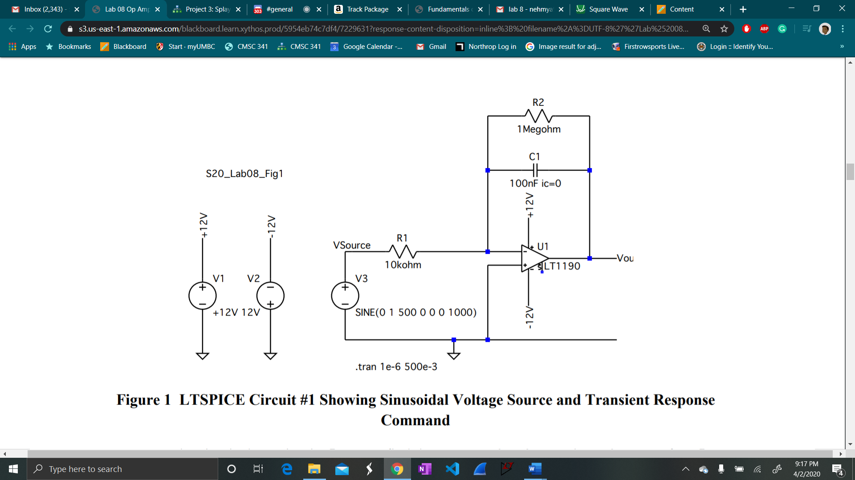

1. Save your circuit and print it to PDF for submission as part of the RESULTS. Then run the simulation. Using the circuit, the differential equation for the capacitor, and your knowledge of op amps, show that this circuit approximates an integrator, where is a gain factor that depends on the frequency and the resistor values. Include this derivation in your lab report (may be handwritten, photographed, and inserted as a picture.)

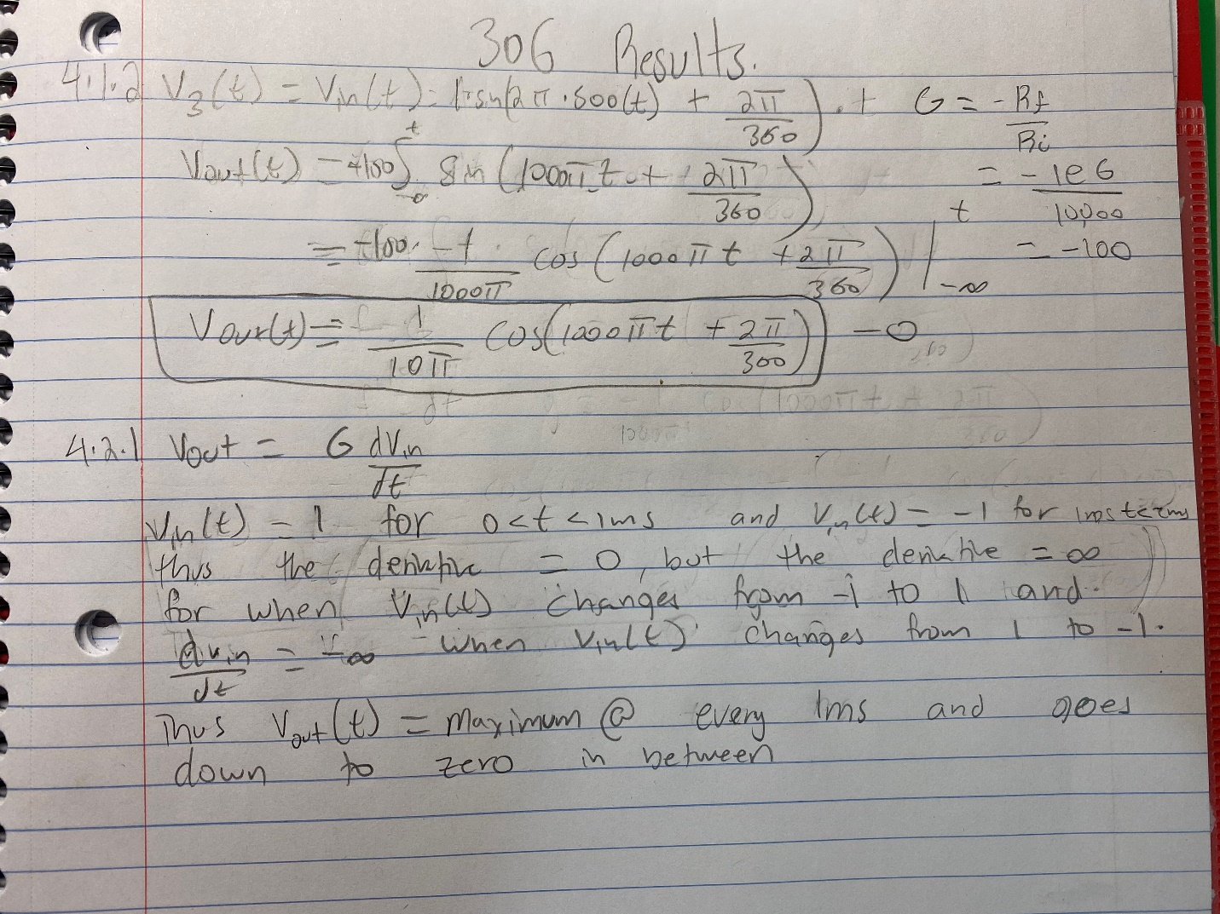

1. From plotting window (which should come up immediately), select the Add Traces option. Add the trace for V(Vsource) and V(Vout).

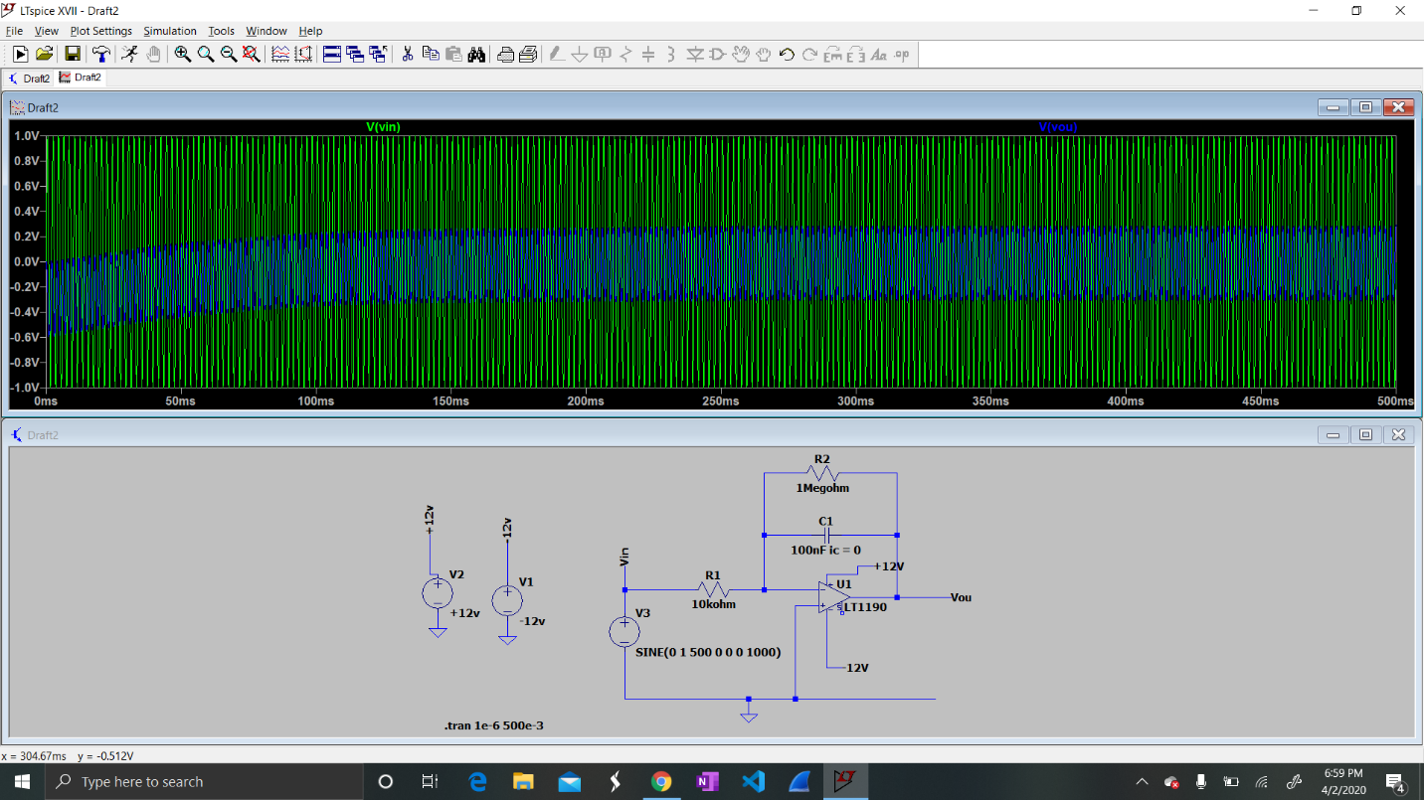

1. Change the time scale of the plot and look at the region between 440 ms and 450 ms. The input voltage is a sine wave. Verify that the output voltage is a cosine wave, with the amplitude computed in Step 3.

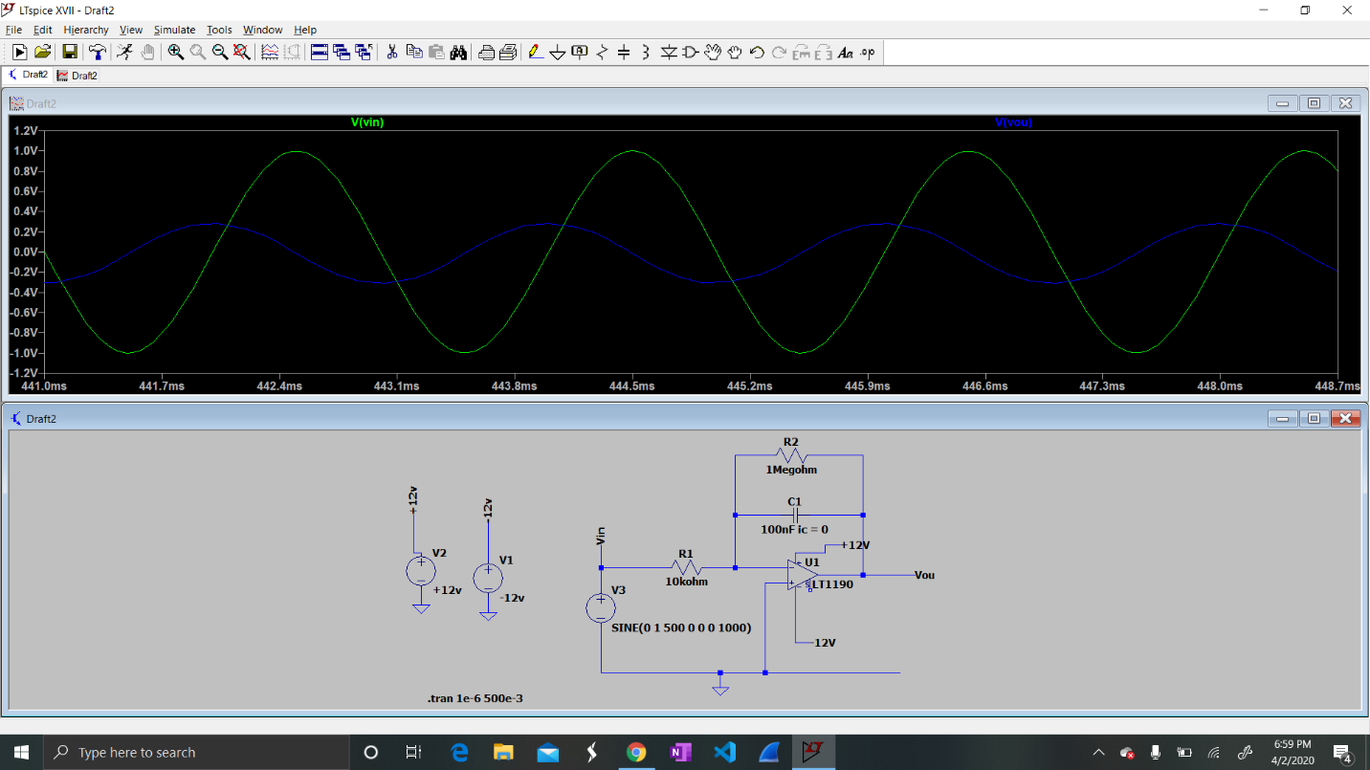

1. Repeat the analysis and simulation for an input sinusoid with frequency 1kHz. Remember that you will need to recompute the frequency-dependent gain term.

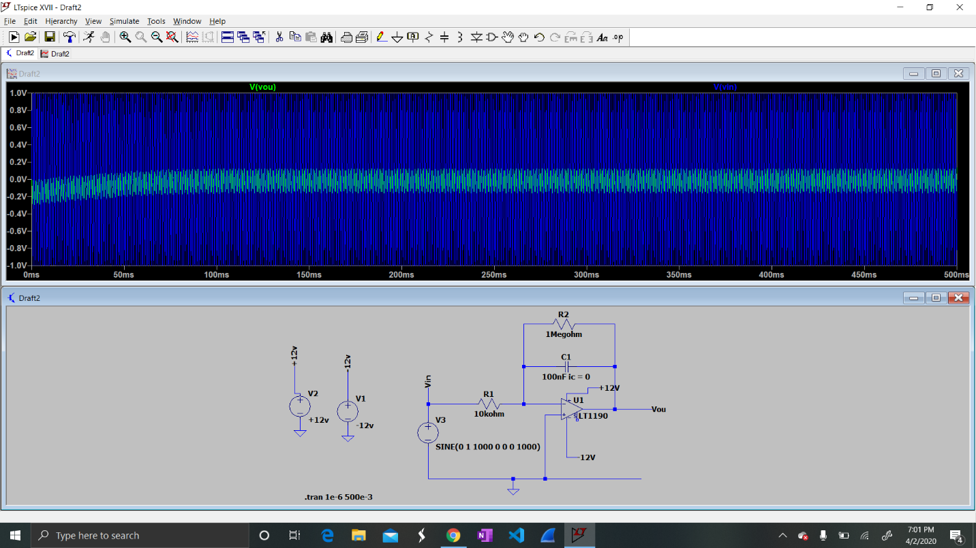

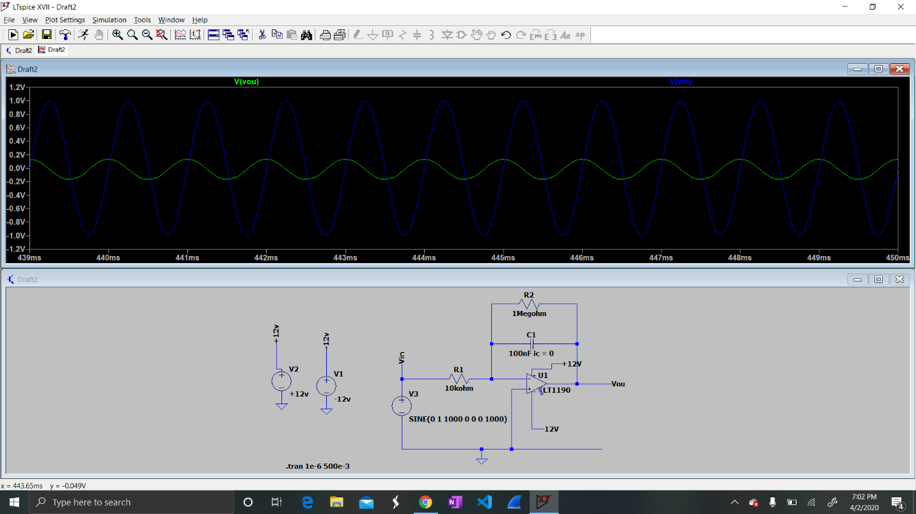

1. Repeat the simulation using a pulsed waveform with a period of 2 ms (1000 pulses/s) with the circuit shown in Figure 4. Plot the input and output on the default scale and then plot on the expanded scale used before.

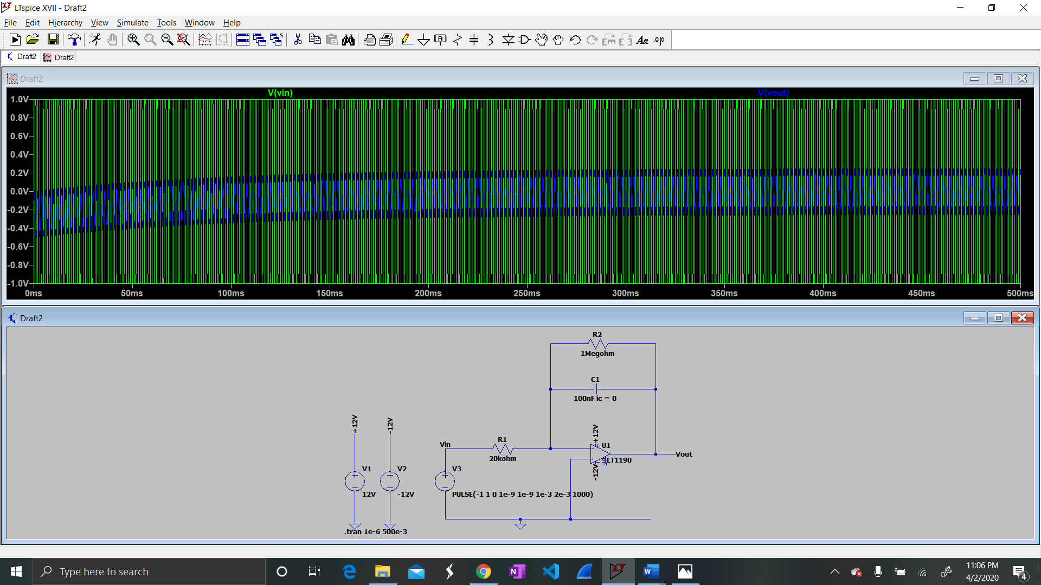

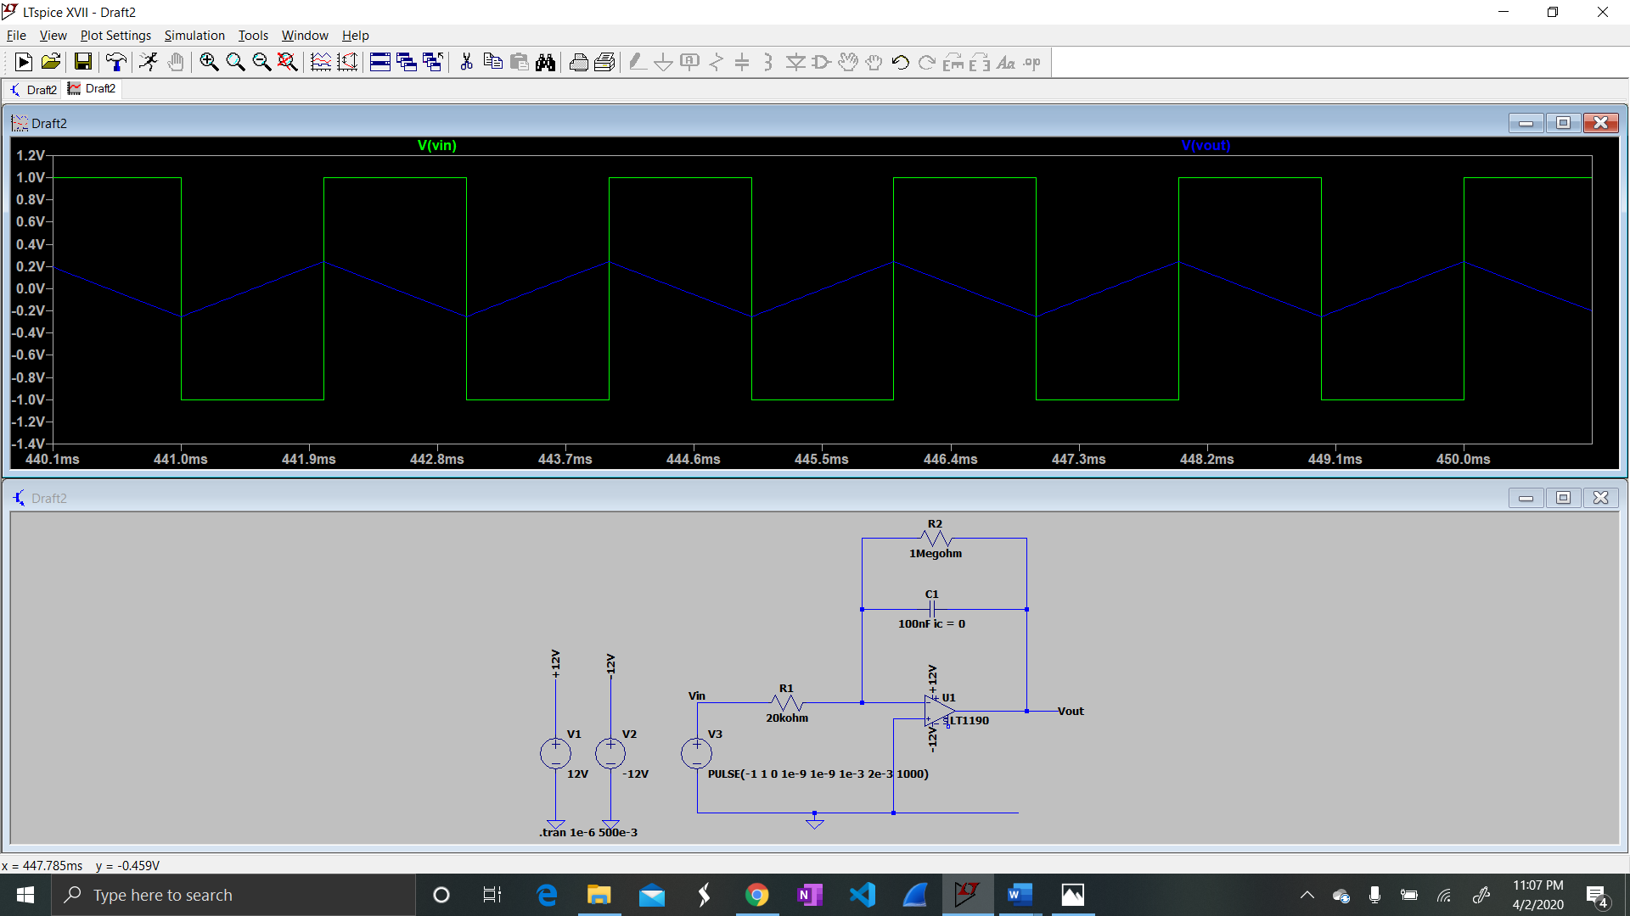

1. Repeat step 6, changing the period to 1 ms. Print the circuit and the plots for submission as RESULTS. In the REPORT, discuss why the integrator output is smaller when the waveform period is shorter.
   1. The Gain factor of the circuit is based on the frequency which is dependent on the period. Thus, when the period changes from 2 ms to 1 ms the gain factor is halved, causing the output voltage to decrease by half. The simulated data below shows that.

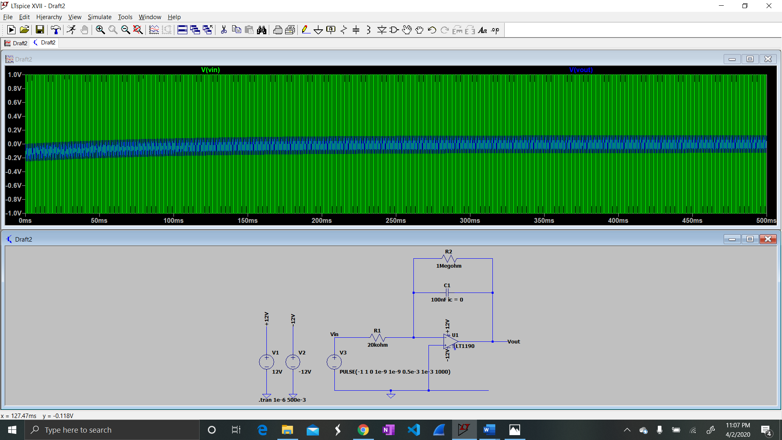

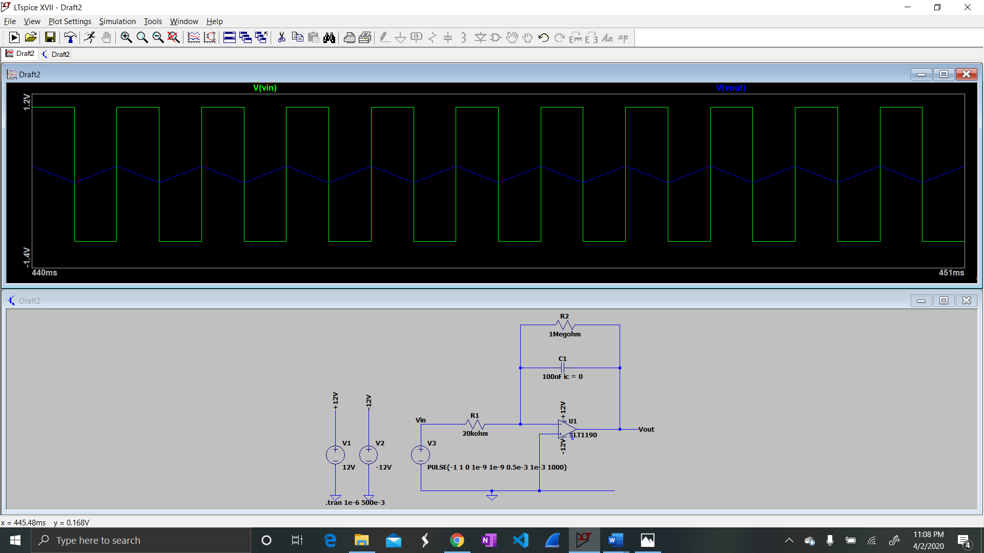

* 1. **Op-Amp based differentiator circuit**

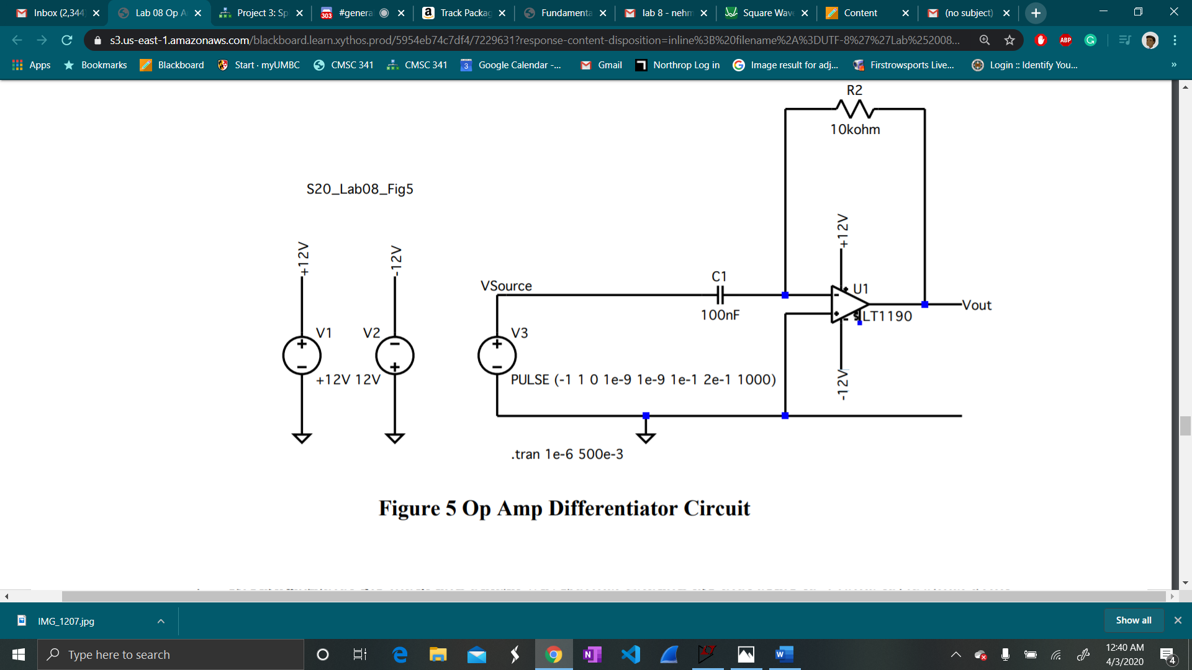

1. Using the circuit, the differential equation for the capacitor, and your knowledge of op amps, show that this circuit approximates an integrator, vOUT (t) ≈ G dvin/dt where is a gain factor that depends on the frequency and the resistor values.

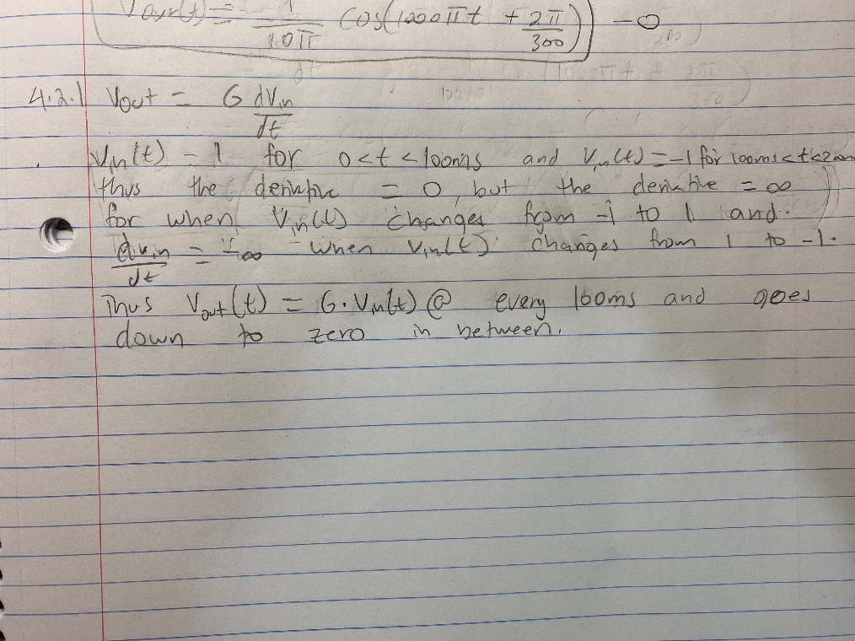

1. Then simulate the circuit. Expand the plot scale to 190ms to 210ms. Print the circuit and plots to PDF for inclusion in the RESULTS and in the REPORT. In the REPORT, explain the large negative-going pulse. Why is the pulse a negative voltage? Why is the pulse amplitude limited to -12V?
   1. The large negative-going pulse of the output voltage is due to the instantaneous change from 1V to -1V. The output voltage is the derivative of the input voltage and the derivative at that point is negative infinity, so the output reaches its maximum possible voltage which is -12V due to the gain factor.

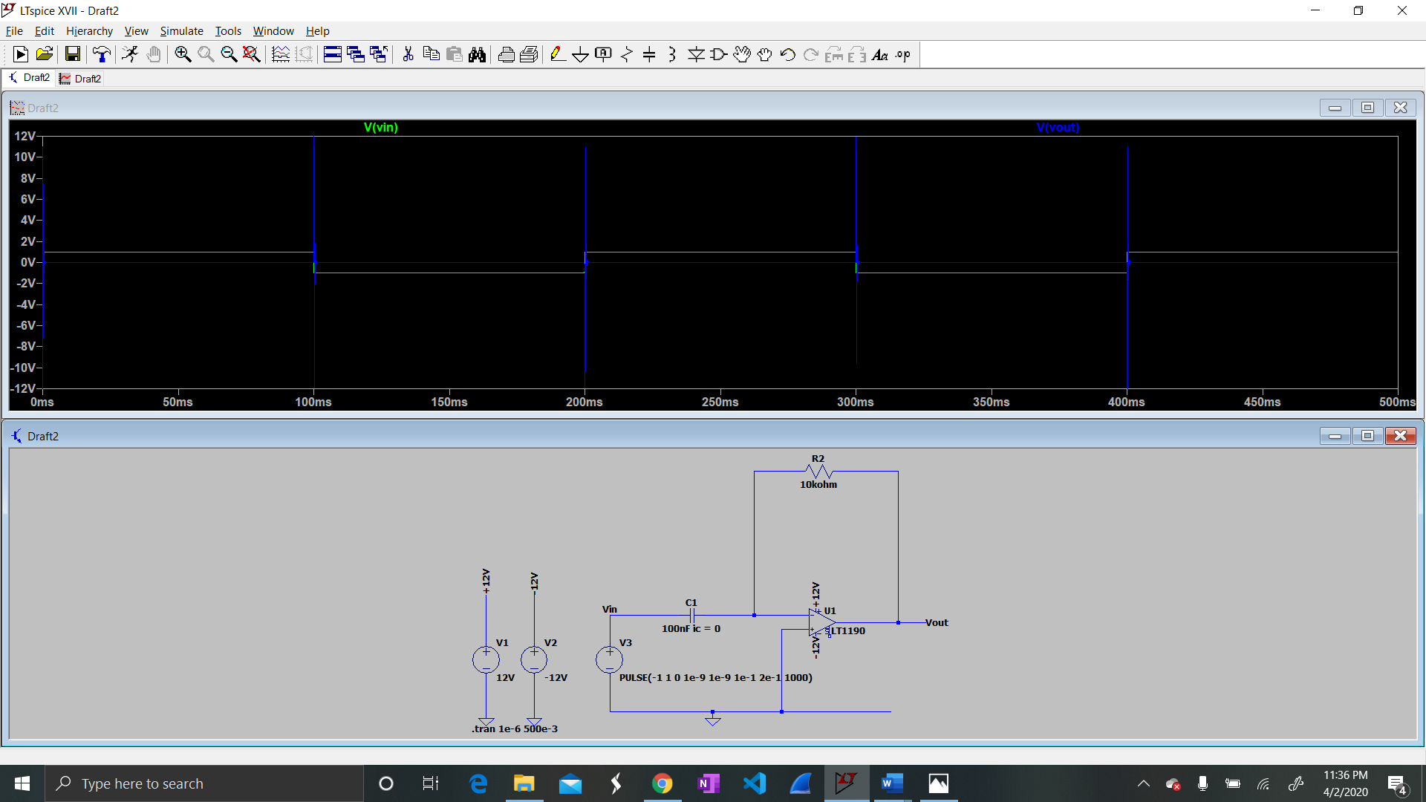

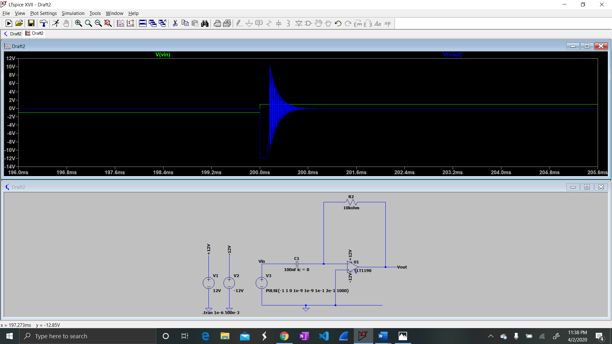

1. Using the definitions from Figure 2, change the source to a sine wave at 500 Hz. Simulate the circuit and plot the input and output waveforms. Expand the plot scale to 440ms to 450 ms. In the REPORT, verify that the circuit is acting as a differentiator, while accounting for the negative gain of the op amp.

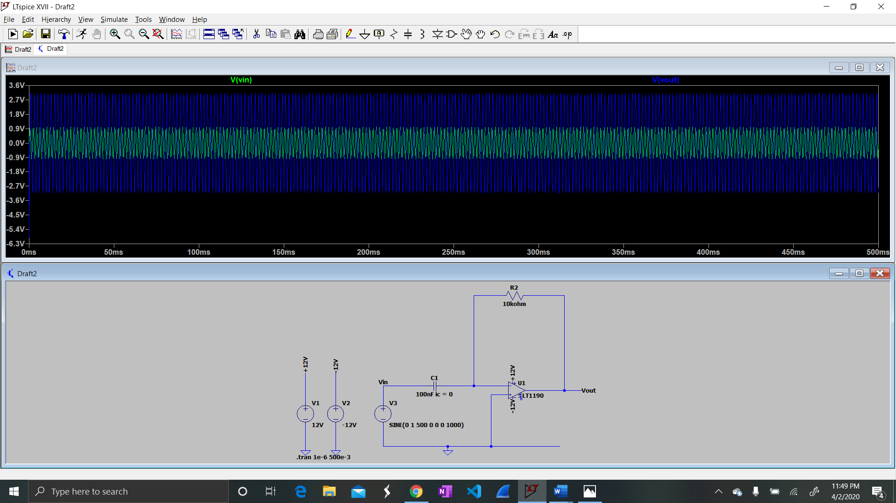

* 1. The input voltage shows a cosine graph while the output voltage shows a sine graph which is the derivative of cosine. The differentiator accounts for the negative gain as the output starts at a negative voltage.

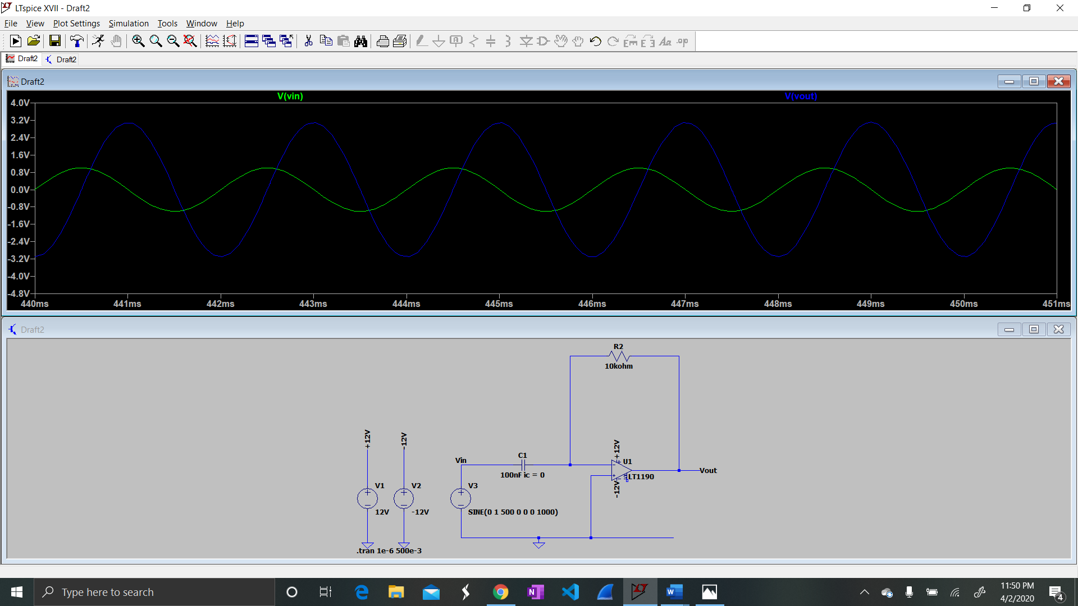

1. Now change the source to create a triangle wave input, as shown in Figure 6. Pay close attention to the parameters in the PULSE definition. Simulate the circuit and plot the input and output waveforms. In the REPORT, explain why the output represent the derivative of the input. Explain the spikes that occur in the output.
   1. The input rises to 1V then does back down to -1V and repeats with a period of 100ms. The output represents the negative derivative of the input. The output is constant because the input voltage is simulated in a linear function. The spikes in the output occur due to the instantaneous change of the slope of the input voltage function.

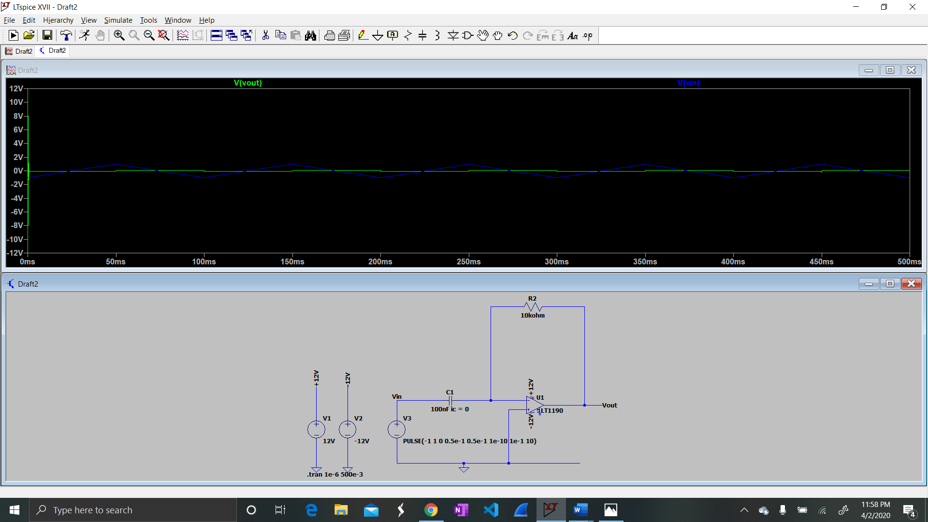

**Conclusion**

In conclusion, circuits can be built to provide integration and differentiation of analog input signals using op amps and capacitors. The integration circuit takes the integral of the input and provides it as the output. The output is also dependent on the gain factor which is dependent on the period of the cycle and the resistors in the circuit. The differentiation circuit takes an input and produces the derivative as the output using op amps and capacitors. The output, just like the integration circuit, is also dependent on the gain factor which is also dependent on the period of a cycle and the resistors within the circuit.